Local Government Commission

Mana Kāwanatanga ā Rohe

To: Local Government Commission

From: Gavin Beattie, Lead Adviser

Date: 6 March 2019

Meeting: 14 March 2019

Subject: Hearing of appeals against the final representation proposal of Kaipara District Council

Purpose
- This briefing provides information for Commissioners in preparation for the hearing of appeals against Kaipara District Council’s final representation proposal.
- The hearing is to be held at 10am on Thursday, 14 March 2019 at Kaipara District Council (the council) at which three of the four appellants have advised they will attend, along with representatives of the council.

Executive Summary
- The council’s initial and final representation proposal is to:
- retain a council comprising a mayor and 8 councillors
- retain a ward system of representation with the addition of a new fourth ward and a small ward boundary alteration
- not establish any community boards in the district.
- There are four appeals against the council’s final proposal. These relate to the proposed ward arrangements.
- The Commission will need to consider both the council’s and the appellants’ views in relation to communities of interest in Kaipara District and whether the proposed arrangements will provide effective representation for these communities of interest, in relation to the proposed wards, and fair representation for electors.

Summary of council’s final proposal
- The council is proposing:
  - a council comprising the mayor and 8 councillors
  - retention of the existing three wards with a minor boundary change, as well as establishment of a new ward for the south-eastern area of the district (see Attachment 1) with representation as follows:
    - West Coast Central Ward: 2 councillors
    - Dargaville Ward: 2 councillors
    - Otamatea Ward: 2 councillors
    - Kaiwaka-Mangawhai Ward: 2 councillors
  - no community boards be established in Kaipara District.

Background

Outcome of council’s last representation review
- The council last conducted a review of its representation arrangements prior to the 2013 local elections. At that time the council’s initial proposal was to retain the existing three wards but to add an additional councillor in order for the proposal to comply with the ‘+/-10% rule’. The initial proposal was also for there to continue to be no community boards in the district.
- Following consideration of submissions on its initial proposal, the council resolved to amend its proposal by retaining the current eight councillors and alter the boundary between two of the wards in order to comply with the ‘+/-10% rule’. The final proposal was also for there to be no community boards.
- One appeal against the council’s final proposal was received.
- Following consideration of the appeal, the Commission determined to endorse the council’s proposal.
- As a result of the Commission’s determination, the following ward arrangements applied for the 2016 elections.

Ward | Population* | Number of councillors per ward | Population per councillor | Deviation from district average population per councillor | % deviation from district average population per councillor
West Coast-Central | 6,910 | 3 | 2,303 | -93 | -3.88
Dargaville | 4,440 | 2 | 2,220 | -176 | -7.35
Otamatea | 7,820 | 3 | 2,607 | +211 | +8.81
Total | 19,170 | 8 | 2,396
*Based on Statistics NZ 2011 population estimates

Preliminary consideration and consultation for current representation review
- The council undertook some informal consultation with the community, by way of a survey, between 30 April and 18 May 2018. A total of 78 responses were received. In summary these showed:
  - 65% wanted a ward system retained, 14% wanted an at large system, 19% wanted a mixed system
  - 44% were happy with the current ward names, 21% were not
  - 55% wanted eight councillors retained, 22% wanted nine councillors
  - 53% wanted community boards, 37% did not.
- At a series of briefings, the council considered a number of representation options. These included seven, eight or nine councillors; three or four wards; a mix of four councillors elected at large and four elected from four wards; at large representation with community boards.

The council’s initial proposal
- At a meeting on 26 July 2018, the council adopted its initial representation proposal. This was for a council comprising the mayor and eight councillors elected from four wards as set out in the following table.
Ward | Population* | Number of councillors per ward | Population per councillor | Deviation from district average population per councillor | % deviation from district average population per councillor
West Coast-Central | 5,830 | 2 | 2,915 | +95 | +3.37
Dargaville | 5,080 | 2 | 2,540 | -280 | -9.93
Otamatea | 5,480 | 2 | 2,740 | -80 | -2.84
Kaiwaka-Mangawhai | 6,170 | 2 | 3,085 | +265 | +9.40
Total | 22,560 | 8 | 2,820
*Based on Statistics NZ 2017 population estimate
- The proposal included a boundary change between the West Coast Central and Otamatea wards involving the transfer of the Ararua/Matakohe area from the West Coast Central Ward to the Otamatea Ward. This would result in a return to the previous boundary altered in the Commission’s 2012 determination in order to achieve compliance with the ‘+/-10%’ rule.
- The proposal was for no community boards to be established in the district.
- The council notified its proposal on 1 August 2018 and called for submissions by 31 August 2018. The council received 81 submissions with 28 supporting the proposal and 53 opposing the proposal.
- The council recorded that those supporting the proposal considered “it makes sense” with proposed ward boundaries reflecting recent growth and tourist numbers, population changes and the summer influx. It also allowed for better and fair representation across the proposed four wards. There was also support for the proposed new Kaiwaka-Mangawhai Ward.
- The council analysed the submissions opposing the proposal as follows:
  - the east/west balance is not adequately addressed
  - there should be nine councillors
  - the Mangawhai area is not adequately represented
  - communities of interest are not appropriately recognised
  - the initial proposal is not democratic
  - use of out of date population data and several out of scope issues.

The council’s final proposal
- At a meeting on 9 October 2018, the Council, after considering the submissions received, adopted its initial proposal as its final representation proposal.
- In notifying its final proposal, the council set out the reasoning for its decision as follows:
  - the east/west balance: the four-ward structure, two in the east (with four councillors) and two in the west (with four councillors) provides balanced representation for the district’s communities and individuals
  - the number of councillors: eight councillors provide fair and effective representation, this was supported by preliminary consultation prior to the initial proposal, plus significant opposition to nine councillors when considered at the last representation review
  - adequate representation of Mangawhai area: the establishment of a new Kaiwaka-Mangawhai Ward (with two councillors) directly addresses the need for representation from the south-east of the district

  - recognition of communities of interest: the proposed ward structure reflects the district’s different communities of interest (specifically reflecting community involvement and access to goods and services)
  - democratic process: the final proposal meets the legislative requirements of identifying communities of interest and providing fair and effective representation.
- The final proposal was publicly notified on 12 October 2018.
- Four appeals against the council’s final proposal have been received as follows:
  - Helen Curren: appeals against proposed ward arrangements and particularly under-representation for the Mangawhai community (Attachment 2)
  - Craig Prouting (on behalf of Hakaru Community Hall and Domain Society: appeals against the name of the Kaiwaka-Mangawhai Ward (Attachment 3)
  - Clive Boonham: appeals against the council’s failure to properly consider the principles of the Local Electoral Act in determining its final proposal and some process issues (Attachment 4)
  - Paul Smith: appeals against the council’s failure to meet the fair representation requirements of the legislation (Attachment 5).

Matters for the Commission’s consideration in determining representation arrangements for Kaipara District

Scope of Commission’s powers
- Section 19R of the Act makes it clear that the Commission, in addition to the consideration of appeals and objections, is required to determine all the matters set out in sections 19H and 19J of the Act which relate to representation arrangements for territorial authorities and for community boards. This interpretation was reinforced by a 2004 High Court decision which found that the Commission’s role is not merely supervisory of a local authority’s representation arrangements decision. The Commission is required to form its own view on all the matters which are in scope of the review.
- Given this requirement, any concerns expressed by appellants/objectors relating to the council’s review process and the impact of this on the council’s decisions, are not matters that the Commission needs to address.

Key considerations
- The Commission’s Guidelines for local authorities undertaking representation reviews identify the following three key factors when considering representation proposals:
  - communities of interest
  - effective representation of communities of interest
  - fair representation for electors.

Communities of interest
- The Guidelines identify three dimensions for recognising communities of interest:
  - perceptual: a sense of identity and belonging to a defined area or locality
  - functional: ability of the area to meet the needs of communities for services
  - political: ability to represent the interests of local communities and to reconcile conflicts between them.
- It is noted that in many cases councils, communities and individuals tend to focus on the ‘perceptual’ dimension. That is, they focus on what intuitively they ‘feel’ are existing communities of interest, often with little evidence to back this up. While this is a legitimate view, more evidence may be required to back this up. It needs to be appreciated that the other dimensions, particularly the ‘functional’ one, are important and that they can also reinforce the ‘sense’ of identity with an area. In other words, all three dimensions are important but should not be seen as independent of each other.
- A sense of identity and belonging can exist as a result of such things as:
  - distinctive physical and topographical features (e.g. mountains, hills, rivers)
  - the history of the area (e.g. how long have the current arrangements been in place and are therefore familiar to residents)
  - similarities in the demographic, socio-economic and/or ethnic characteristics of the residents of a community
  - similarities in economic or social activities carried out in the area
  - identification with sports/recreation/social teams from the area.
- Ability to meet the needs of communities for services (council and non-council) is another important dimension which provides coherence for communities of interest. As noted, this can also reinforce the sense of identity with an area through dependence on common facilities and services. The ‘functional dimension’ of communities of interest includes local services and facilities such as:
  - schools (particularly primary schools)
  - shopping centres
  - health services
  - community, recreational and cultural facilities and services
  - employment
  - transport and communication links.
- Identification of political/representation/interest group structures in an area will assist in the recognition of the ‘political dimension’ of communities of interest. These structures include the likes of:
  - residents and ratepayer associations
  - the rohe or takiwā of local iwi and hapū
  - special interest groups.
- In addition to evidence of this type to assist the recognition of existing communities of interest, evidence may also need to be provided of differences between neighbouring communities i.e. they may have “few commonalities”. This could include the demographic characteristics of an area (e.g. age, ethnicity, deprivation profiles) and how these differ between areas, and evidence of how different communities rely on different service facilities.
- Kaipara District covers an area stretching from the west coast to the east coast of Northland Region and includes the northern part of the Kaipara harbour. As part of the current representation review, the council records the district as comprising four defined communities of interest: the urban township of Dargaville; the rural western central/coastal area; the rural central inner harbour area; and the rural/urban eastern coastal area (includes Mangawhai described on the council’s website as becoming increasingly popular as a lifestyle and holiday destination).

Effective representation of communities of interest
- Section 19T of the Act requires that the Commission ensures that:
  - the election of members of the council will provide effective representation of communities of interest in the district
  - ward boundaries coincide with the boundaries of the current statistical meshblock areas determined by Statistics New Zealand and used for parliamentary electoral purposes
  - so far as is practical, ward boundaries coincide with community boundaries.
- While not a statutory requirement, the Commission’s Guidelines also suggest that local authorities consider the total number of members, or range in the number of members, necessary to provide effective representation for the district as a whole.
- Section 19A of the Act provides that a territorial authority shall consist of between 5 and 29 members, excluding the mayor. Kaipara District Council comprised a mayor and 10 councillors on its constitution in 1989 until the 2007 elections when this number was reduced to the current eight councillors.
- Councils can achieve effective representation of communities of interest by having members elected:
  - by wards
  - at large
  - a mixture of wards and at large.
- The Commission’s Guidelines note the following factors need to be considered when determining effective representation for the council:
  - avoiding arrangements that may create barriers to participation, such as at elections by not recognising residents’ familiarity and identity with an area
  - not splitting recognised communities of interest between electoral subdivisions
  - not grouping together two or more communities of interest that share few commonalities of interest
  - accessibility, size and configuration of an area including access to elected members and vice versa.
- Four wards were established when the district was constituted in 1989 and remained until the 2007 elections when the number of wards was reduced to the current three. As part of the 2013 review, the council did consider options for re-establishing a fourth ward in the south-eastern area of the district but these failed to attract strong council and community support.
- There appears to be continuing clear majority support for a ward system of representation in Kaipara District. Some debate does continue, however, over the most appropriate number of wards. In addition to the council’s proposal to increase the number of wards from three to four, there was consideration of a two-ward structure by combining the West Coast-Central and Dargaville wards and retaining the current Otamatea Ward (to include the proposed Kaiwaka-Mangawhai Ward). Such a proposal was moved at the council meeting adopting the final proposal with the motion to adopt it tied between those for and against, and defeated on the mayor’s casting vote.
- In relation to the number of wards, and more particularly the number of members per ward, it is noted that Kaipara District Council has adopted the STV electoral system. It is generally agreed that larger multi-member wards (at least three-member wards) or at large systems are necessary to achieve proportional representation under this system.
- One of the appeals goes into some detail about community of interest connections in the eastern area of the district and particularly between Kaiwaka (in the proposed new ward) and Maungaturoroto (in Otamatea Ward). Commissioners may wish to question the council further on the basis for its four-ward structure and achievement of effective representation for communities of interest.
- It is also noted that Northland Regional Council is proposing to retain its Coastal South Constituency which involves a boundary separating the Kaiwaka and Mangawhai settlements from other areas to the south (on the Oneriri Peninsula) which are all within the new proposed Kaiwaka-Mangawhai Ward of Kaipara District. This raises further questions about communities of interest in this area on which Commissioners may wish to seek the views of Kaipara District Council.
- Finally, it is noted that one appellant has raised the name of the proposed new ward, suggesting ‘Eastern Ward’ would be more appropriate recognising that the area covers other settlements beyond Kaiwaka and Managawhai.

Fair representation for electors
- Section 19V(2) of the Act requires that, with certain prescribed exceptions, the population of each ward divided by the number of members to be elected by that ward produces a figure of no more than 10 per cent greater or smaller than the population of the district divided by the total number of elected members (the ‘+/- 10% rule’).
- The council’s proposal complies with the rule. Two appellants do note, however, the Dargaville and Kaiwaka-Mangawhai wards are at the extremes of the +/-10% range. Two appellants refer to projected population change in certain parts of the district with one suggesting another option “that is robustly tolerant of population change and meets all other criteria”. While projected population is not a statutory criterion, Commission officers consider it can be used as an argument to support a particular decision.

Should there be communities and community boards within the district
- Section 19J of the Act requires territorial authorities, whether or not they currently have community boards, to consider whether there should be communities and community boards and, if so, the nature of any community and the structure of any community board. This consideration is to be in light of the principle of fair and effective representation for individuals and communities.
- As part of this consideration a territorial authority, and where appropriate the Commission, are also required by section 19W to have regard to such of the criteria as apply to reorganisation proposals under the Local Government Act 2002 as it considers appropriate. Two of those criteria are seen as having particular significance for reviews relating to community boards:
  - Will the community have an area that is appropriate for the efficient and effective performance of its role?
  - Will the community contain a sufficiently distinct community of interest or sufficiently distinct communities of interest?
- There have been no community boards in Kaipara District since its constitution in 1989. The council is not proposing to establish any community boards and none of the appeals raise this issue as a prime concern.

Attachment 1
Proposed Kaipara wards

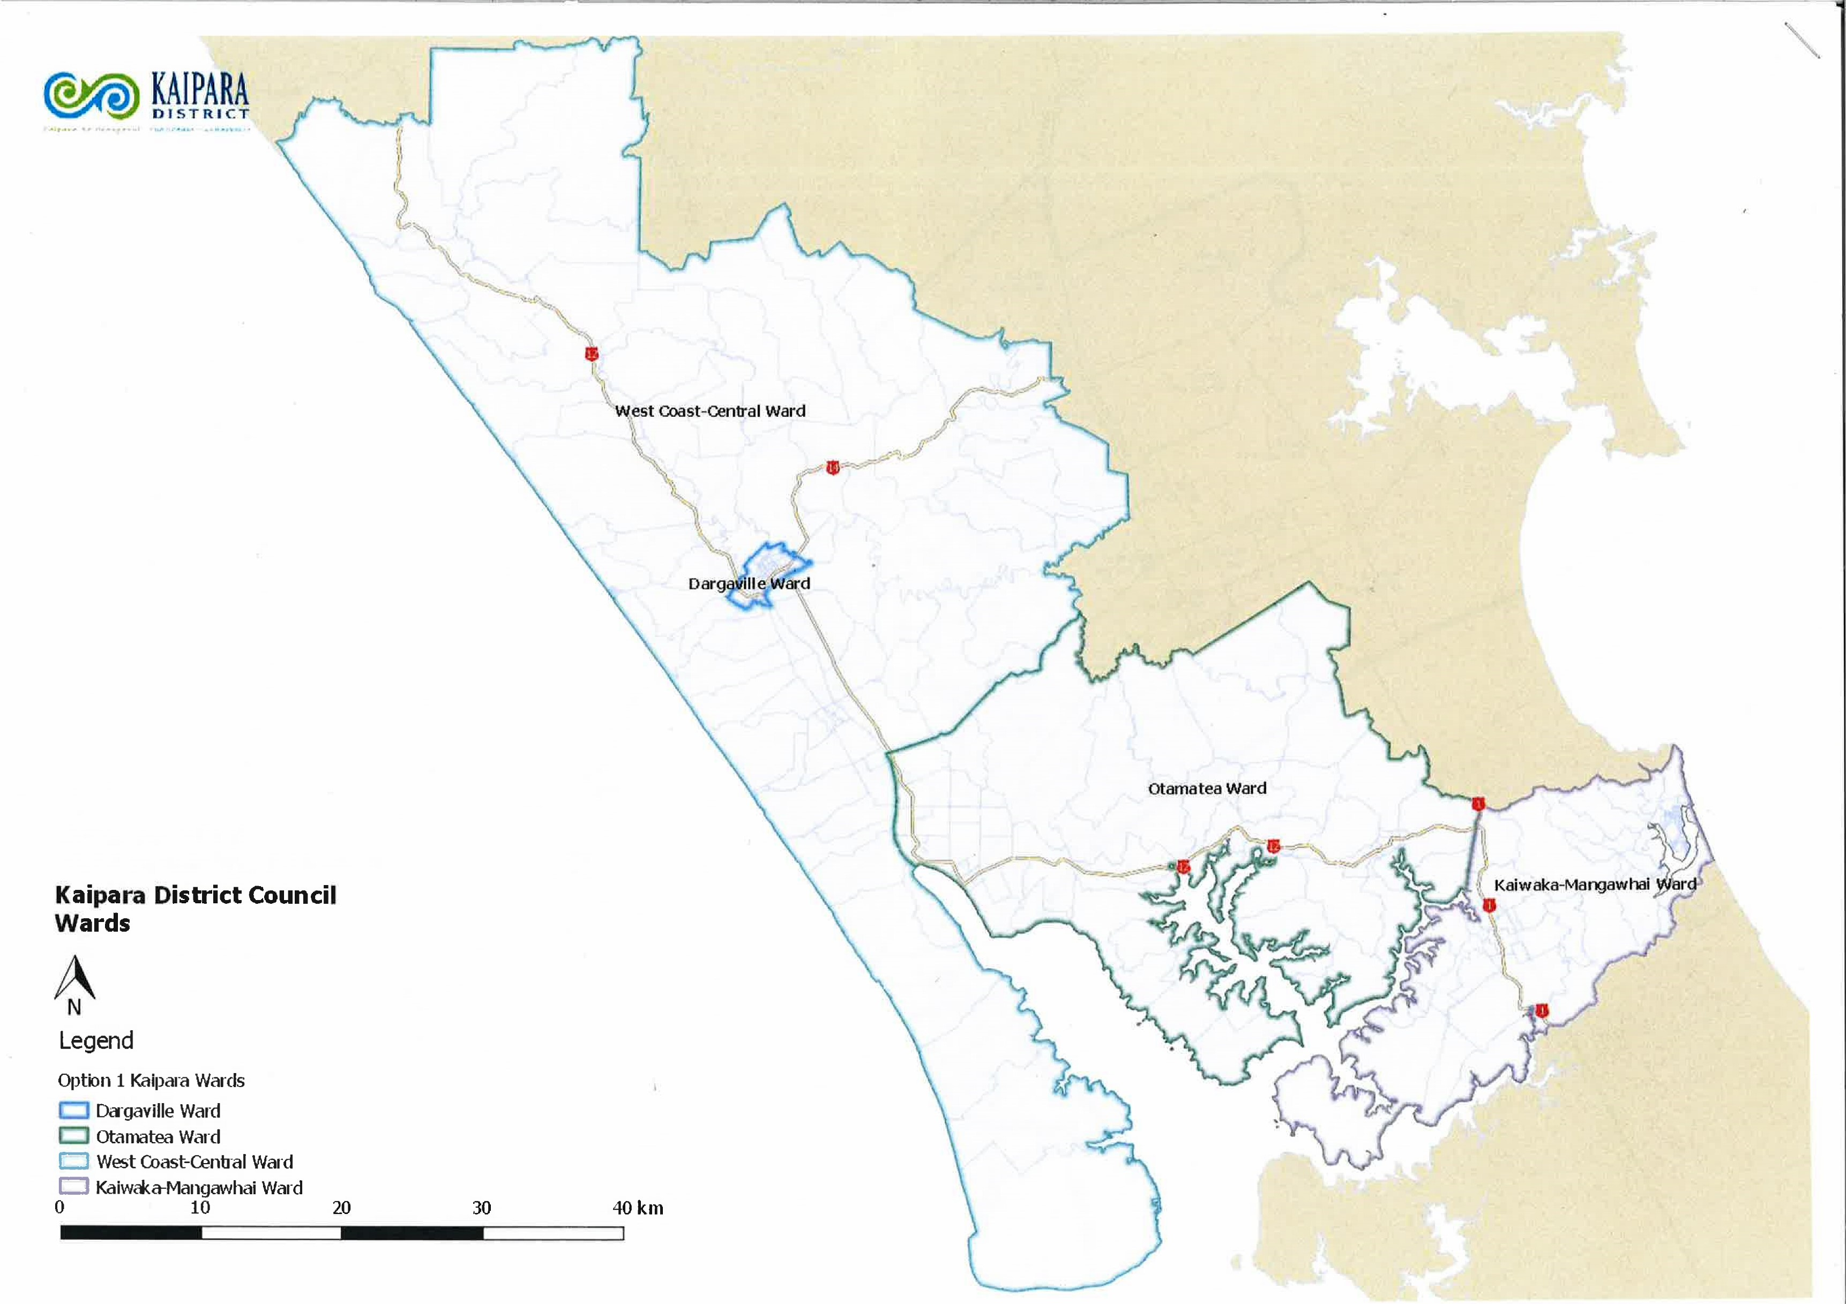

Attachment 2
Appeal to Local Government Commission re Kaipara Representation Arrangements.
The – 9.8% deviation favours Dargaville and the + 9.55% disadvantages Mangawhai . I also appealed the council representation decisions in 2012 for similar reasons.
There is a very long and very unfortunate history to the repeated and serious under representation of the Mangawhai Community. Very costly and badly managed projects have left a legacy of debt and environmental problems.
Many Mangawhai ratepayers are not all year resident so don’t get to be counted for statistical purposes. They are nevertheless ratepayers in a rapidly growing district and council should have reversed the above 10% ratios to reflect that known imbalance.
It seems that council didn’t think broadly enough about possible solutions to the representation arrangements problems. Councillors at large with community boards and reducing the number of counsellors were all options which did not seem to be considered. Mesh block boundaries have been juggled in the past so arguments about communities of interest don’t fly.
Helen Curreen

Attachment 3

APPEAL FORM
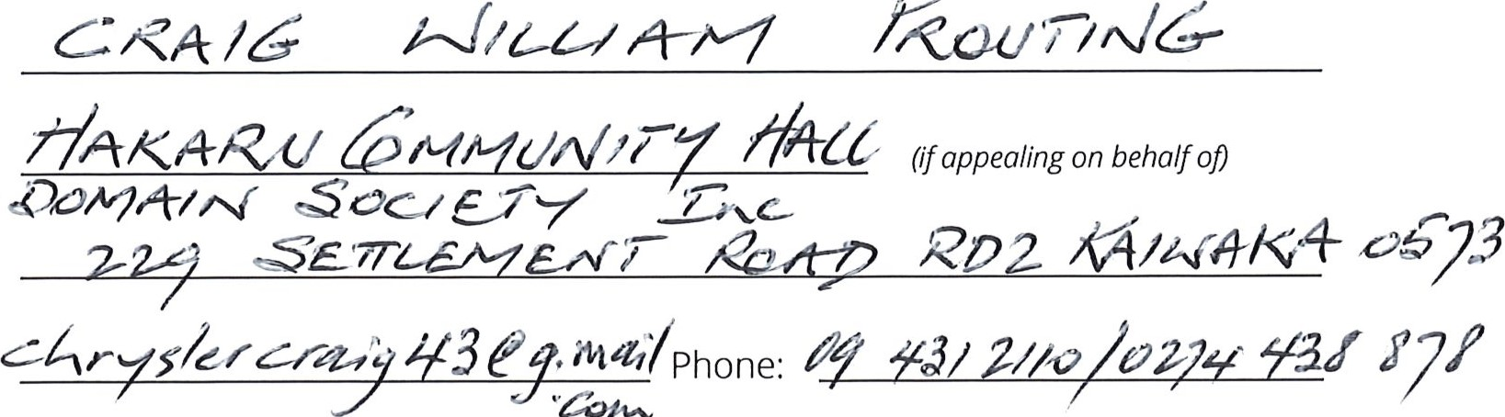
Full Name:
/6
ROU
Organisation: r
Postal Address:
Email:

I oppose the Council's proposed representation review arrangements for the 2019 elections (Final Proposal).
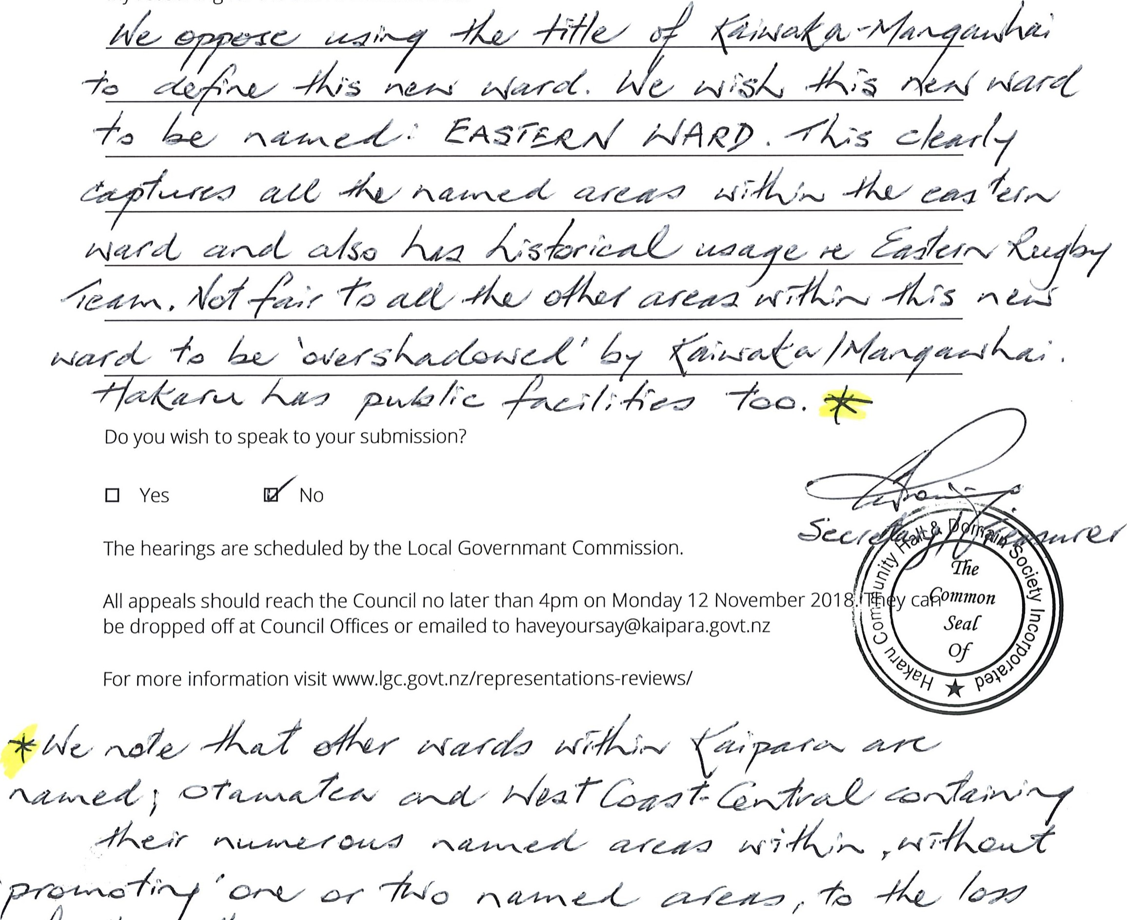
My
reasoning
for
the
above
statement
is...

Attachment 4
APPEAL AGAINST THE KAIPARA DISTRICT COUNCIL’S FINAL PROPOSAL FOR REPRESENTATION REVIEW ARRANGEMENTS FOR THE 2019 ELECTIONS
Clive Richard Gerald Boonham PO Box 401005 cliveboonham@gmail.com
094314723
________________________________-
I oppose the Council’s proposed representation review arrangements for the 2019 elections (Final Proposal).
My reasons for opposing the proposed arrangements are set out below.
_____________________________________________________________

KDC FAILED TO PROPERLY CONSIDER THE THREE KEY PRINCIPLES
In deciding to adopt its initial proposal as its final proposal the Council erred by failing to properly consider the three key principles of Part 1A of the Local Electoral Act 2001 as per the Local Government Commission’s Guidelines for local authorities (the Guidelines) undertaking representation reviews, June 2017.
As describe in the Guidelines “The statutory requirements described in these guidelines are binding on both local authorities and the Commission itself in the exercise of its powers on objections, appeals and referrals. The other content in these guidelines describes recommended practice for the review process.” (page 3, emphasis added)

Communities of interest
Council’s public notice published on 12 October advertising the final proposal stated that “The proposed ward structure adequately reflects the District’s different communities of interest (specifically reflecting community involvement and access to goods and services)”.
Previous Local Government Commission reviews have identified a number of factors that contribute towards defining a community of interest. In adopting the initial proposal as the final proposal the Council failed to consider the following factors –
The Otamatea ward is a long established community of interest with its genesis in the former Otamatea County Council. The final proposal divides off the Kaiwaka and Mangawhai part of the current Otamatea ward to create a new ward.
The history of the area - the current Otamatea ward is a long established community of interest with its genesis in the former Otamatea County Council. Residents identify as being members of this long established entity.
Physical and topographical features – the current Otamatea ward has shared physical and topographical features, small townships, rolling countryside and harbour inlets.
A sense of community identity and belonging, dependence on shared facilities in an area, including schools, recreational and cultural facilities and retail outlets – there is a sense of community identity and belonging that arises from the shared history of the current Otamatea ward.
The final proposal divides Kaiwaka from the current Otamatea ward. Kaiwaka Primary School has a long historical connection with its associated high school, Otamatea High School at Maungaturoto. Otamatea High School has for many years united the children and communities of Kaiwaka, Maungaturoto and Paparoa with their shared seven years of intermediate and senior schooling.
The privately owned and run school Westmount, is also based in Maungaturoto but draws also from Kaiwaka as well as more widely.
The Coast to Coast medical practice at Maungaturoto is the medical practice used by Kaiwaka residents as the closest available.
The pharmacy in Maungaturoto likewise is the pharmacy used by Kaiwaka residents for prescriptions and general pharmaceutical sales.
There is a very strong business community of interest between Kaiwaka and Maungaturoto, principally in the businesses run by the Brethren community. These businesses constitute by far the largest group of employers in the area and that community is largely based in Maungaturoto and in Kaiwaka.
The other major employment provider is Fonterra which draws staff from both areas.
Maungaturoto is the retail hub for Kaiwaka residents in a number of areas: hardware, building products, veterinary services, farming products, electronic goods, stationery, a butchery and also offers a service for some banking transactions. It is also the closest source of fish and chips and pizza. It offers choice for vehicle repairs, tyre services, health food products and vehicle sales.
Otamatea Community Services which is a significant provider of various social services, is based in Maungaturoto and covers from Paparoa to Mangawhai.
The Maungaturoto Rotary Club in fact covers from Paparoa to Mangawhai. Northpower has a servicing centre in Maungaturoto.
Maungaturoto has a rest home, a retirement village and is currently building a dementia facility and is used by many people from Kaiwaka as their closest and obvious choice.
On a less formal level, there are many links between people, with common pioneers, farms straddling the two areas and constant travel between the two townships for markets, sports events, musical productions and school special occasions. We share much of the district history in common and the same names crop up in the stories of the past for both Maori and Pakeha. The final proposal will undermine this sense of community, identity and belonging.
Similarities in the demographic, socio-economic and/or ethnic characteristics of a community, and similarities in economic activities – there is no discernible division between the various parts of the current Otamatea ward which is comprised of rural and coastal townships, lifestyle properties, and farms. The economic activities are shared across the current Otamatea ward with rural support businesses, farming, forestry, construction and tourism predominating.

Effective representation
The Local Government Commission’s Guidelines provide principles that territorial authorities can apply when considering the issue of effective representation. KDC has failed to have proper regard these principles as follows –
A recognised community of interest should not be split between electoral boundaries – the final proposal divides Kaiwaka from the rest of the current Otamatea ward to the West. Kaiwaka has a strong historical and social connection with Maungaturoto, with Kaiwaka Primary School being one of the three feeder schools for Otamatea High School at Maungaturoto. This means that an important community of interest will be divided by the final proposal.
Accessibility, size and configuration of an area should be considered – the current Otamatea ward works well in relation to these principles. Councillors traverse the current Otamatea ward to attend Council meetings at both Dargaville and Mangawhai on a regular basis. Councillors of the current Otamatea ward are able to have reasonable access to, and provide reasonable access to the population of the ward. They are able to represent the views of the residents of the ward effectively, and are able to attend public meetings throughout the ward, and to provide reasonable opportunities to have face-to-face meetings with constituents.

Fair representation
The final proposal (which as required by the legislation) uses old population statistics results in fair representation figures that are right on the margin for both the new Kaiwaka/ Mangawhai ward and the West Coast Central ward. The figures are –
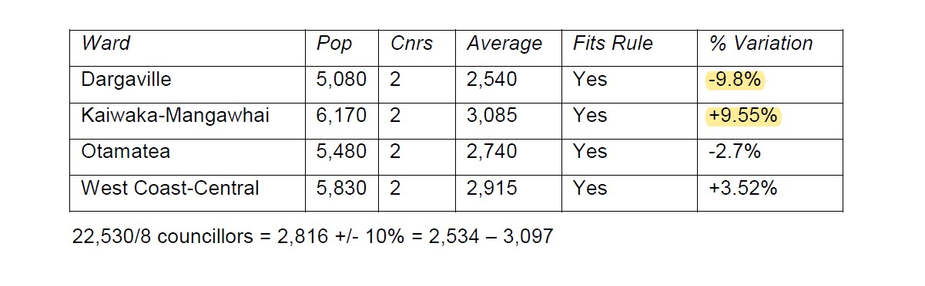
This has particular negative consequences for the Kaiwaka- Mangawhai Ward which is at +9.55%. Given that the population of the Kaiwaka-Mangawhai area is growing very rapidly and these are old figures then it is almost certainly already in breach of the +10% threshold in actuality (check the latest census figures).
This means that at the next review the threshold will be officially breached and the boundary will have to be moved further to the West towards Maungaturoto. In fact the continuing population growth in the Kaiwaka-Mangawhai error will require the boundary to be moved incrementally towards Maungaturoto not only in the next review but most likely in all subsequent reviews. This will unnecessarily create confusion and uncertainty for residents with constantly changing ward boundaries.
Similarly the initial proposal also places the Dargaville ward right on the negative margin at -9.8%. Dargaville is a declining town with a stagnant population. This is also unnecessarily creating an issue with boundaries likely to be required to be moved with population decline or even just to maintain average parity with the required margins when influenced by the strong growth of Kaiwaka – Mangawhai.
Ironically one of the other options considered and of equal popularity amongst the elected members was option 2A which provides much superior margins for changes in population for both of the wards balanced at +3.4% for Otamatea ward and – 3.16% for Wairoa ward.
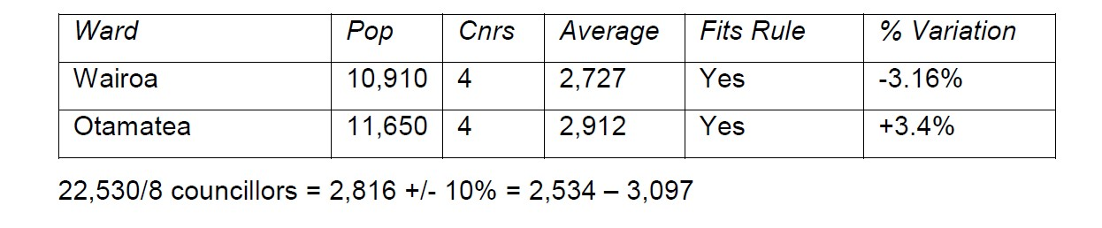
This means that the boundaries can be maintained through at least one or two further representation reviews without confusing changes every time.
The KDC document titled ‘Representation review- effective representation for Kaipara District Council’ states that ‘…we’re able to review our wards and boundaries in three years’ time when we will use 2018 Census information, and will have an up to date grasp on the population movements across Kaipara and the country’.
Changing ward boundaries and configurations to the extent being proposed under the final proposal will unnecessarily cause disruption to residents’ sense of community, identity and belonging. If KDC proceeds with the final proposal it will almost certainly need to change boundaries again in three years’ time when it undertakes a further review with new information as described in point 3 above.
Proposal 2A addresses all of the concerns raised above. It does not divide established communities of interest or conflate communities with limited commonality. It provides for better effective representation in the current Otamatea ward without providing poorer effective representation in the West Coast Central ward.
Any argument against combining Dargaville with West Coast central is a red herring. Dargaville is the main urban link for the West Coast central ward – they are very closely aligned. Both of the current Dargaville councillors don’t even live in the Dargaville ward (the both live in the West Coast central ward) and manage to represent the interests of Dargaville effectively.
There is further benefit of combining Dargaville and West Coast Central. Under the final proposal West Coast Central which covers a huge geographical area loses a Councillor (from three down to two). By combining with Dargaville as proposed under option 2A it will allow four Councillors to spread the workload over Dargaville and West Coast Central evenly rather than having only two Councillors for the very large West Coast Central ward area.
The reasons given in the public notice for the final proposal were –
- the east/west imbalance: The four ward structure, two in the east (with four councillors) and two in the west (with four councillors) provides balanced representation to the District’s communities and individuals;

- the number of councillors: Eight councillors provide fair and effective representation, this was supported by preliminary consultation undertaken prior to the initial proposal, plus significant opposition to nine councillors when considered at the last representation review;

- adequate representation of Mangawhai area: The establishment of a new KaiwakaMangawhai Ward (with two councillors) directly addresses the need for representation from the south-east of the District;

- recognition of communities of interest: The proposed ward structure adequately reflects the District’s different communities of interest (specifically reflecting community involvement and access to goods and services);

- democratic process: The final proposal meets the legislative requirements of identifying communities of interest and providing fair and effective representation.
Option 2A satisfies all of these reasons, Mangawhai is already represented and would continue to be better represented with the addition of another Councillor to the Otamatea ward, but is superior to the final proposal because it does not operate right on the margin for fair representation
As an alternative option 3A also satisfies all of the concerns raised and remains at good neutral margins for fair representation as shown below –
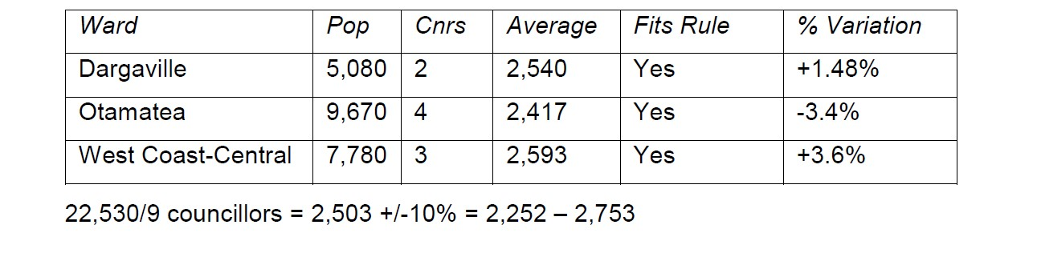
It does however require the addition of one more councillor giving a total of nine Councillors.

THE ELECTED COUNCIL WAS PRESENTED WITH INCORRECT INFORMATION AND SUMMARY INFORMATION ABOUT SUBMISSIONS THAT DID NOT CORRECTLY REPRESENT WHAT THE SUBMISSIONS ACTUALLY STATED
The extraordinary agenda says at page 13 regarding the two ward 8 councillor option 2A–
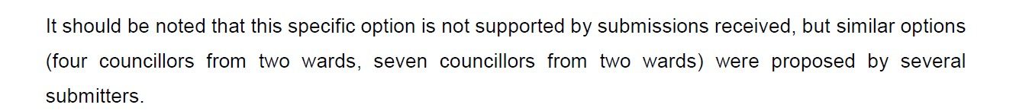
However Paul Smith’s submission (page 193 of compiled submissions) specifically sets out an option with 2 wards and 8 councillors specifically –
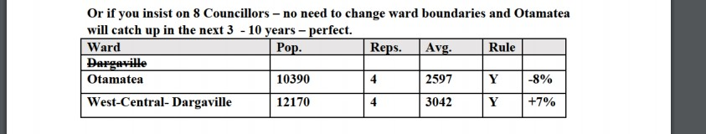

DECISION-MAKING NON-COMPLIANT WITH LEGISLATION AND GUIDELINES
Paragraph 9.22 of the Commission’s Guidelines states:
9.22 If a local authority receives submissions on its initial proposal, it must ensure that it acts in a legally 'fair' way in considering them. For instance, if any person exercises the right to be heard under section 19M(3) of the Local Electoral Act 2001 it is typically appropriate that only local authority members who hear the submissions participate in the decision-making on those submissions. If an elected member has very good reason for being unable to attend oral submission presentations, it may be possible for them to still participate in the decisionmaking, provided that they take all reasonable steps to inform themselves about the oral submissions concerned.

Attendances at the representative review hearings
11 September 2018 from 9:30am to 10:31am
Four members were present: Mayor Jason Smith (Chair), and Councillors Anna Curnow, Karen JoycePaki and Jonathan Larsen.
Apologies were recorded for Councillors del la Varis-Woodcock, Jones, Wade and Wethey.
Councillor Geange was absent.
Council briefing on the representation review held on 21 September 2018 from 10am to 1145am Four members were present: Mayor Jason Smith (Chair), Deputy Mayor Peter Wethey and Councillors Libby Jones, and Jonathan Larsen.
Karen Joyce-Paki (via audio link 10.42 am—11.20 am)
Apologies were recorded for Councillors Anna Curnow, Victoria del la Varis-Woodcock, Julie Geange and Andrew Wade.

Extraordinary meeting of Council held on 9 October 2018 from 10:02am to 11:44am
Members present: Mayor Jason Smith, Deputy Mayor Peter Wethey, Councillors Anna Curnow, Victoria del la Varis Woodcock, Julie Geange (via audio link), Libby Jones, Karen Joyce-Paki and Jonathan Larsen.
An apology was recorded for Councillor Wade.
The Guidelines indicate that those Councillors who did not attend the review hearings and hear oral submissions – some did not attend any - should not have been able to participate in the decisionmaking on those submissions. But they did.
There is no evidence that they took reasonable steps to inform themselves about the oral submissions concerned as requires by 9.22.
Accordingly the KDC and its elected representatives failed to meet their statutory obligations in the decision-making process.

SUMMARY OF SUBMISSIONS DOCUMENT MISREPRESENTED THE SUBMISSIONS AGAINST THE INITIAL PROPOSAL
The Agenda of the extraordinary meeting held on 9 October 2018 includes a document titled Summary of submissions (page 16).
The document does not properly summarise the issues raised in the submissions including ignoring valid points about the marginal nature of the fair representation figures resulting from the initial proposal.
In addition the same document made negative comments about some of the submissions
The Summary states that the 53 opposition submissions included 24 submissions using the proforma submission as published on Kaipara Concerns website. The Summary then goes on to add:
There were a number of common themes that were presented in the submissions that opposed the Initial Proposal. This is to be expected, given that nearly half of the submissions received were made using the pro-forma submission previously mentioned.
With respect, those comments were completely unwarranted and do not give a fair and independent assessment of the submissions. Those statements are clearly aimed at diminishing the importance of submissions of those who opposed the Initial Proposal and used a pro-forma submission form.
They reflect a bias against any submissions supporting alternative proposals, were highly prejudicial to the democratic process, and may have influenced the Councillors when casting their votes.
We live in a democracy which entitles the people to exercise their democratic right by casting their votes in many different circumstances. In nearly all situations the vote is a Yes or a No indicated by a tick in a box. No reasons are given. When we elect a government we tick a box and do not have to give reasons why we support the party voted for. When KDC Councillors cast a vote on the Initial Proposal they simply voted for or against. No reasons had to be given.
So why are the opinion of the pro-forma submitters unfairly devalued? They voted against the proposal. That should be enough on its own. But they also gave persuasive reasons. The fact that others gave the same reasons is completely irrelevant. That’s what happens when you vote for or against an issue or have a referendum.
Could it simply be that the comments highlight a bias against any submission that opposed the Initial Proposal?
Would such negative comments have been made if pro-forma submissions had been made in favour of the KDC’s preferred option?
This was a complicated issue. The guidelines and concepts are difficult and the permutations and possibilities mind-stretching. The pro-forma document used by some submitters was prepared from the submissions of those who had given serious consideration to the issues. It represented the views of many ratepayers of Otamatea who feel that the KDC is perpetuating its strategy of disenfranchising the ratepayers of Otamatea. Those submitters who endorse that sentiment were fully entitled to use the pro-forma submission. They did not blindly use the form. They used it because the pro-forma submission represented the collective views of many ratepayers in Otamatea, and the submitter agreed with those views.
In short, the summary of submissions did not fairly reflect the arguments of submitters with alternative proposals and may have misled the elected members into voting for initial proposal when in fact one of the alternatives offered a better alternative.

GROUNDS OF APPEAL IN RESPECT OF NON-COMPLIANCE WITH STATUTORY REQUIREMENTS
There are two issues which are technically outside the scope of an appeal by a submitter under section 19O because they were not raised in my earlier submissions.
They could not be raised in my submissions because they arose subsequent in time to the filing of my submissions.
They are important issues in that they go to the root of the legality of the decision-making of the KDC in respect of its final proposal.
The two issues are:
- Non-compliance with the Local Electoral Act 2001

- Non-Compliance with LGA 2002 and standing orders in respect of Mayor’s casting vote

Non-compliance with the section 19N(2) of the Local Electoral Act 2001
The relevant provisions of the Guidelines are:
9.23 Each local authority needs to consider all submissions received, and must be able to demonstrate that it has done this by providing reasons for the acceptance or rejection of submissions.
9.24 The local authority’s public notice of its final proposal under section 19N(2) is required to state the reasons for amendments and the reasons for any rejection of submissions, so the reasons must be recorded in the local authority’s resolution of its final proposal.
Section 19N(2) requires:
- The reasons for rejection of submissions must be stated in the public notice of the final proposal and the local authority’s resolution of its final proposal.

- This requires the local authority to state the reasons for “any rejection of submissions”. This must relate to each point in each submission.
The public notice of the final proposal lists a very brief synopsis of the issues raised by submitters in opposing the initial proposal:
Those that opposed the initial proposal identified the following issues:
  - the east/west imbalance is not adequately addressed;
  - there should be nine councillors;
  - the Mangawhai area is not adequately represented;
  - communities of interest are not appropriately recognised;
  - initial proposal not democratic;
  - use of outdated data and other out of scope issues.
The public notice does not identify any submissions supporting alternative proposals.
In respect of the statutory requirement to state the reasons for any rejection of submissions the public notice states:
A number of submissions highlighted out of scope issues. These issues raised (use of outdated population data, lack of provision for future growth, rating per head of population and reduction to four councillors) were excluded as they fell out of the scope of factors available for consideration.

This reason only relates to the reason for excluding that particular issue in “a number of submissions”. The public notice fails to state the reasons why all other issues in those submissions and in other submissions, either opposing the initial proposal or proposing alternative proposals, were rejected, as required by section 19N(2).
The public notice does state Reasoning around the decision to continue with the initial proposal. However that does not meet the statutory requirement to state the reasons for rejecting the submissions opposing the initial proposal or supporting alternative proposals. There is no evidence that the alternative proposals did not meet those same criteria.

Non-Compliance with LGA 2002 and Standing Orders in respect of Mayor’s casting vote
At the extraordinary council meeting of 09 October 2018 the Council passed two resolutions in respect of the final representation arrangements. In both cases the vote was tied and the Mayor used his casting vote. In the first case he used his casting vote against a motion proposing an alternative proposal with the result that it was lost. In the second case he used his casing vote so that the motion to make the initial proposal the final proposal was carried.
Copies of both resolutions are set out below.

Option 2A
At the extraordinary Council meeting of 09 October in 2018 the motion to adopt option 2A was tied (with one member absent) and the Mayor used a casting vote to defeat it, as shown in the minutes below –
Amendment (2) moved Larsen/Wethey
That Kaipara District Council:
- Receives the Electoral Officer’s Report “Representation Review: Final Proposal” dated 25 September 2018; and

- Believes it has complied with the decision-making provisions of the Local Government Act 2002 to the extent necessary in relation to this decision; and in accordance with the provision of s79 of the Act determines that it does not require further information prior to making a decision on this matter; and

- Resolves, pursuant to section 19N of the Local Electoral Act 2001, to adopt, as its final proposal for the review of representation arrangements for the 2019 and 2022 triennial local body elections, the following option:
Option 2A – Amend the Initial Proposal as the Final Proposal (see Attachment 2 of the aforementioned report)
Eight councillors, plus the mayor, two wards these being a new Wairoa Ward
(Dargaville and West Coast-Central Wards from Initial Proposal) (four councillors) and a new Otamatea Ward (Kaiwaka-Mangawhai and Otamatea Wards from Initial Proposal) (four councillors), no community boards; and
- Issues a public notification on 12 October 2018 that informs the public of the final proposal and the opportunity to make an appeal or objection in the period 12 October to 12 November 2018 should they wish to; and
- Delegates to the Mayor and Chief Executive the authority to review and approve the wording of the reasons for the Council’s decision, and its rejection of submissions received on the Council’s initial proposal.
A division was called, and voting was as follows:

For Against Absent
Councillor Geange Councillor Curnow Councillor Wade
Councillor Jones Councillor del la Varis-Woodcock
Councillor Larsen Councillor Joyce-Paki
Councillor Wethey Mayor Smith
The motion was declared TIED.
Mayor Smith voted AGAINST, and the amendment motion was declared LOST.

Resolution adopting the initial proposal as the final proposal

SCROLL DOWN
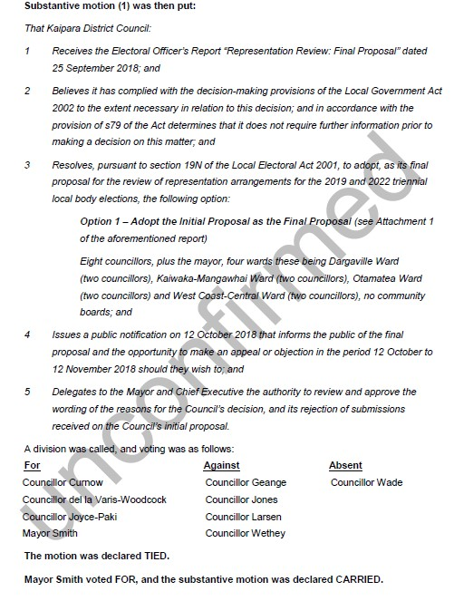
It is submitted that the use of the casting vote by the Mayor in such circumstances was in breach of the LGA 200 and in breach of standing orders.

Factual background

- The deadline for action under section 19N(1) was 12 October 2018, being 6 weeks after the end of the consultation period of 1 August 2018 – 31 August 2018. That statutory period gave the KDC ample time to hear submissions, provide a report on the submissions, consider the submissions and the report, to pass the appropriate resolution and give public notice of the final proposal.

- This was an important issue for the district and involved consideration of effective and fair representation for the next election. It was therefore vital and quite fundamental that all elected representatives should have an input and a vote on the proposed representation arrangements.

- Councillor Wade could not attend the extraordinary meeting on the day arranged because of a prior commitment in Auckland. He was not available for a single day only.

- There was a 6 week period for the KDC to perform its obligations. It should have ensured that a meeting was held where all elected members could be present, so that they could have their say and vote on the proposals. Standing orders permit to extraordinary meetings to be scheduled within 24 hours, so an alternative date could have been scheduled to suit all elected members.

- Alternatively the Council could have quite easily have made arrangements pursuant to clauses 12.7 and 12.9 of the standing orders whereby councillor Wade could have cast his votes remotely. Councillor Geange cast her votes in this way at the same meeting.

- Councillor Wade was only away for a single day. Standing order 8 allows extraordinary meetings to be called with 24 hours notice. An extraordinary meeting could have been called with Councillor Wade in attendance and the 6 week requirement could still have been met.

Legal situation
The Minutes recite the following under paragraph 3.1:
Pursuant to Clause 24(2), Schedule 7 of Local Government Act 2002, the Mayor has a casting vote for issues of statutory compliance and deadlines. Due to Section 19N(1) of the Local Electoral Act 2001, the Mayoral casting vote applies to the following motions and resolutions for this item
The statement that the Mayor has a casting vote in the circumstances described carries no weight from a legal point of view. The question is whether the use of the casting vote complied with the legislation and standing orders.
Section 24(2) of the LGA states:
24 Voting
(1) The acts of a local authority must be done, and the questions before the local authority must be decided, at a meeting by—
    - vote; and
    - the majority of members that are present and voting.
(2) For the purposes of subsection (1), the mayor or chairperson or other person presiding at the meeting—
    - has a deliberative vote; and
    - in the case of an equality of votes, does not have a casting vote (and therefore the act or question is defeated and the status quo is preserved).
  - An act or question coming before the local authority must be done or decided by open voting.
  - Subsections (1) and (2) apply unless—
  - this Act provides otherwise; or
  - the standing orders of the local authority expressly provide otherwise.
An analysis of section 24 shows that a Mayor does not have a casting vote under section 24(2) unless the standing orders of the local authority expressly provides otherwise.
The KDC standing orders state:
18.3 Chair has a casting vote
The Mayor or any other person presiding at a meeting has a deliberative vote. In the case of issues of statutory compliance and deadlines the Mayor (or Chair in his absence) will have a casting vote.
Statutory compliance is a very general term. Local authorities are creatures of statute and virtually every decision made by a local authority arises because of the need for statutory compliance. However, in this instance there was no need for a specific resolution to be passed such as the need to adopt the annual plan or set rates. This was a “free” vote with no element of statutory compliance. Elected representatives were entitled to cast their votes in respect of representation in any way they chose.
Likewise “deadlines” means very little. Most decisions made by a local authority are subject to some sort of deadline or time constraint.
In this instance, section 19N(1) of the Local Electoral Act allowed the KDC a 6 weeks’ period in which to carry out its statutory obligations which culminated in elected members having a free vote on the representation proposals. That is ample time to perform its obligations and ensure that all elected members were available to vote on such an important issue.
It is therefore submitted that the use of the casting vote by the Mayor in respect of both resolutions was non-compliant with standing orders. Consequently clause 249(2)(b) of Schedule 7 of the LGA 2002 applied and the Mayor had no casting vote. Both resolutions were therefore defeated and the status quo was preserved. This means that the KDC did not lawfully adopt the initial proposal as its final proposal.
_____________________________-

REMEDY SOUGHT

I seek the following remedy –
Either –
Amend the initial proposal as the final proposal to conform to Option 2A described on page 6 of the agenda of Council’s extraordinary meeting held on 9 October 2018 being –
Eight councillors, plus the mayor, two wards these being a new Wairoa Ward (Dargaville and West Coast-Central Wards from Initial Proposal) (four councillors) and a new Otamatea Ward (KaiwakaMangawhai and Otamatea Wards from Initial Proposal) (four councillors), no community boards;
Or –
Amend the initial proposal as the final proposal to conform to Option 3A described on page 6 of the agenda of Council’s extraordinary meeting held on 9 October 2018 being –
Nine councillors, plus the mayor, three wards these being the current Dargaville Ward (two councillors), the current Otamatea Ward (four councillors) and the current West Coast-Central Ward (three councillors), no community boards.

I wish to speak to my submission.

12 November 2018

Attachment 5
Representation Review

APPEAL FORM
Full Name: Paul Smith

Organisation: | Resident | (if appealing on behalf of)
Postal Address: | 443 Pahi Rd, RDI Paparoa, 0571

Email: gracelandz@gmail.com Phone: 0220 186 386
I oppose the Council's proposed representation review arrangements for the 2019 elections (Final Proposal).
My reasoning for the above statement is...
The proposal agreed by the council FAILS to meet the fair representation by number criteria as set out in the applicable legislation.
To approve such an arrangement knowingly is in breach of the trust with which every councillor is obliged to operate.
In my submission I proposed an 8 councillor solution that is robustly tolerant of population change and meets all other criteria with minimal disruption of existing ward characteristics.
I believe the council is clearly negligent in adopting the proposal of choice and am very concerned that the culture of ignoring the law of governance continues in KDC with apparent impunity.

Do you wish to speak to your submission?
X Yes No
The hearings are scheduled by the Local Governmant Commission.
All appeals should reach the Council no later than 4pm on Monday 12 November 2018. They can be dropped off at Council Offices or emailed to haveyoursay@kaipara.govt.nz
For more information visit www.lgc.govt.nz/representations-reviews/

On 6 September 2012, the Minister of Local Government appointed four commissioners to perform and exercise the responsibilities, duties and powers of the Kaipara District Council. The Gazette notice of these appointments advised that the October 2013 triennial elections of the council were cancelled and the next general election of the council would be held on 17 October 2015. The Commission’s determination was therefore to apply to those elections. Subsequently, the 2015 election was not held with the next election held at the time of the 2016 triennial local authority elections.
The motion to adopt the initial proposal was tied between those for and against, and the motion was carried on the mayor’s casting vote.

